1. **Agenda**:
   1. Test Runner.
2. 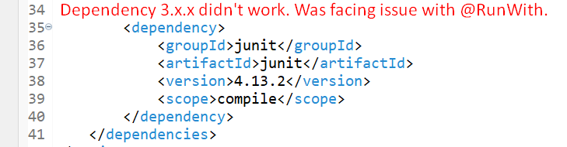
3. 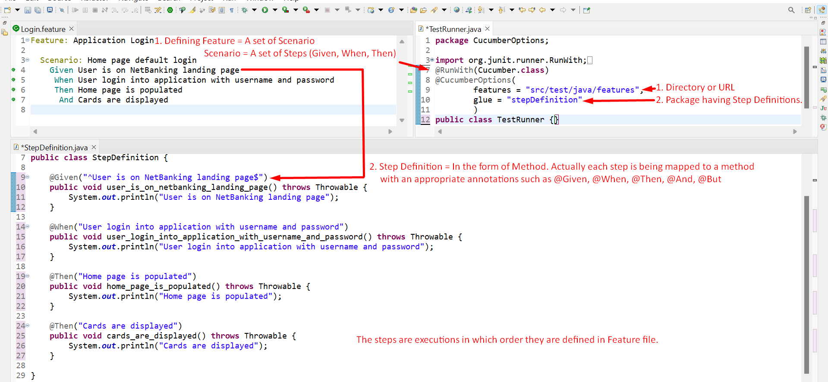
4. @CucumberOptions(stepNotifications=true)  
   Graphical user interface, application

   Description automatically generated
5. 